**AWS: Login:** [koomalkcATgmail.com](mailto:koomalkc@gmail.com)

*ari*a**@

**(**How to connect to EC2 w/ PuTTY (Windows)

<https://www.youtube.com/watch?v=bi7ow5NGC-U>

[**ubuntu@ec2-18-222-201-215.us-east-2.compute.amazonaws.com**](mailto:ubuntu@ec2-18-222-201-215.us-east-2.compute.amazonaws.com)

**UbuntuNew**

**Host Name: ec2-18-222-201-215.us-east-2.compute.amazonaws.com**

**ec2-18-222-201-215.us-east-2.compute.amazonaws.com**

**ec2-18-222-201-215.us-east-2.compute.amazonaws.com**

**"Sundari.pem"** [**ec2-user@ec2-13-59-143-213.us-east-2.compute.amazonaws.com**](mailto:ec2-user@ec2-13-59-143-213.us-east-2.compute.amazonaws.com)

**"Sundari.pem" ubuntu@ec2-18-222-201-215.us-east-2.compute.amazonaws.com**

**AWS Cloud Practitioner**

<https://www.youtube.com/watch?v=h5jaLL0jHSQ>

**IAM users sign in link**

**https://048660715605.signin.aws.amazon.com/console**

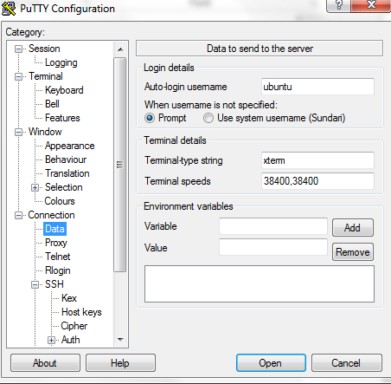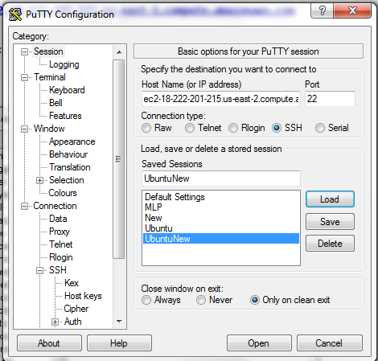  
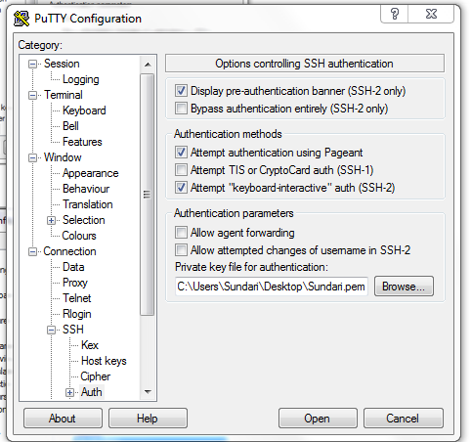

Service-EC2----Running Instances

